TITLE
Author’s name¹ – Author’s name² – Author’s name³
¹affiliation
²affiliation
³affiliation
author’s email, author’s email, author’s email
General information
The abstract should not exceed two A4 size page, with margins of 2.5 cm on each side. An additional third page may include figures, tables, and references. The figures and tables do not have to appear on the third page, if you whish to involve them between the paragraphs of the text. The font type should be TNR, the line spacing should be single (see font size below).
The abstract should follow this structure: 1. Introduction, 2. Methods, 3. Results, 4. Conclusion, References.
Title
The title of the abstract and the name of the author(s) should be typed in 12 pt font size, the affiliation(s) and email addresses in 12 pt, centered. The title of the abstract should be in bold and capitalized, followed by a space of 6 pt; the name of the author(s) should also be bolded, but here only the initial letters should be in capitals, followed by a space of 6 pt. There should be a space of 6 pt after the affiliations and 18 pt after the email address(es).
Main text
The main text should be 12 pt and justified. If there is a chapter title, it should be in bold (can be numbered). Do not indent the first line of paragraphs.
If there is a figure, it should be single line-paced centered, and a blank line should be inserted in front of it. The numbered figure title should be in bold and italics below the figure (see Figure 1), and a blank line should be inserted after it.

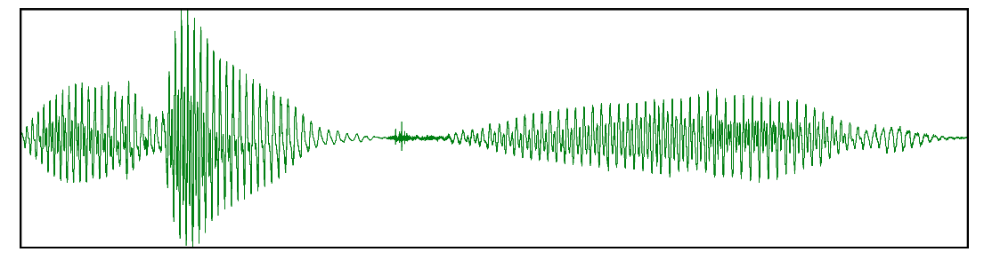
Figure 1. An oscillogram

If there is a table, it should also be centered and a blank line inserted before it, its title should be numbered and positioned below the table, then a blank line should be inserted again (see Table 1). A font size of 12 pt should be used within the table as well.

 | Hungarian authors | Foreign authors
Single author presentations | 45 | 21
Presentations with more than one author | 87 | 93
Table 1. Conference participants

Sources should be given the title References; this title should be bold but not numbered, and a space of 12 pt should be inserted before it. Only those sources that appear in the main text should be included in the References section and all citations should be resolved in the list of sources. Reference items should be displayed with 1 cm hanging indent and justified as shown below:
References
Patel, R. – Grigos, M. I. 2006. Acoustic characterization of the question–statement contrast in 4, 7 and 11 year-old children. Speech Communication 48/10. 1308–1308.
Sanders, J. – Spooren, W. 1997. Perspective, subjectivity, and modality from a cognitive linguistic point of view. In: Liebert, W.-A. – Redeker, G. – Waugh, L. (eds.): Discourse and perspective in cognitive linguistics. Amsterdam, Philadelphia: John Benjamins. 85–112.
Verschueren, J. 1999. Understanding pragmatics. London: Edward Arnold.

