TITLE
Author’s name¹ – Author’s name² – Author’s name³
¹affiliation
²affiliation
³affiliation
author’s email, author’s email, author’s email
General information
The revised abstract should be in .pdf format, and should not exceed three A4 size pages, with margins of 2.5 cm on each side, including tables, figures, acknowledgements, and references. The font type should be TNR, the line spacing should be single (see font size below). Please, do not use page numbering, header, or footer. The abstract should follow this structure: Introduction, Methods, Results, Conclusion, Acknowledgements, References.
Title
The title of the abstract and the name of the author(s) should be typed in 12 pt font size, the affiliation(s) and email addresses in 12 pt, centered. The title of the abstract should be in bold and capitalized, followed by a space of 6 pt; the name of the author(s) should also be bolded, but here only the initial letters should be in capitals, followed by a space of 6 pt. There should be a space of 6 pt after the affiliations and 18 pt after the email address(es).
Main text
The main text should be 12 pt and justified. Chapter titles should be in bold. Do not indent the first line of paragraphs.
If there is a figure, it should be single line-paced, centered, and a blank line should be inserted in front of it. The numbered figure title should be in bold and italics below the figure (see Figure 1), and a blank line should be inserted after it.
If there is a table, it should also be centered and a blank line inserted before it, its title should be numbered and positioned below the table, then a blank line should be inserted again (see Table 1). A font size of 12 pt should be used within the table as well.
Sources should be given the title References; this title should be bold but not numbered, and a space of 12 pt should be inserted before it. All tables and figures have to be referred to in the main text.
Only those sources that appear in the main text should be included in the References section and all citations should be resolved in the list of sources. Reference items should be displayed with 1 cm hanging indent and justified as shown below.

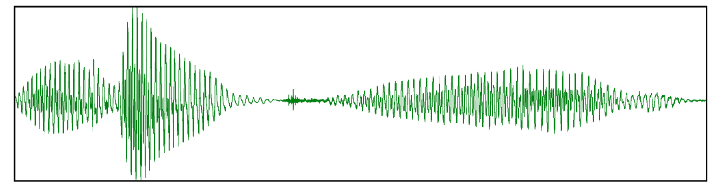
Figure 1. An oscillogram

 | Hungarian authors | Foreign authors
Single author presentations | 45 | 21
Presentations with more than one author | 87 | 93
Table 1. Conference participants

Acknowledgements
The acknowledgements should be formatted like the main text.
References
Patel, R. – Grigos, M. I. 2006. Acoustic characterization of the question–statement contrast in 4, 7 and 11 year-old children. Speech Communication 48/10. 1308–1308.
Sanders, J. – Spooren, W. 1997. Perspective, subjectivity, and modality from a cognitive linguistic point of view. In: Liebert, W.-A. – Redeker, G. – Waugh, L. (eds.): Discourse and perspective in cognitive linguistics. Amsterdam, Philadelphia: John Benjamins. 85–112.
Verschueren, J. 1999. Understanding pragmatics. London: Edward Arnold.

